|  |  |  |
| --- | --- | --- |
| Project Design Document | |  | | --- | | *08/10/2020*  Bartek Oskam | |

|  |  |  |  |
| --- | --- | --- | --- |
| Project Concept | | | |
| 1 **Player Control** |  | You control a   |  | | --- | | *Rocketship* | | in this   |  |  | | --- | --- | | *top Down* | game | |
|  | where   |  | | --- | | *Arrow keys or wasd* | | makes the player   |  | | --- | | *Turn and blast forwards* | |

|  |  |  |  |  |  |  |
| --- | --- | --- | --- | --- | --- | --- |
| 2 **Basic**  **Gameplay** |  | During the game,   |  |  | | --- | --- | | *Meteorites and aliens* | appear | | from   |  | | --- | | *Off screen* | |
|  | and the goal of the game is to   |  | | --- | | *Survive as long as possible* | | |

|  |  |  |  |  |  |
| --- | --- | --- | --- | --- | --- |
| 3 **Sound**  **& Effects** |  | There will be sound effects   |  | | --- | | *when shooting*  *destroying alines*  *destroying meteorites*  *dying* | | and particle effects   |  | | --- | | *when shooting*  *destroying alines*  *destroying meteorites*  *dying* | |
|  | [*optional*] There will also be   |  | | --- | | *Moving stars in the background* | | |

|  |  |  |  |  |  |
| --- | --- | --- | --- | --- | --- |
| 4 **Gameplay**  **Mechanics** |  | As the game progresses,   |  | | --- | | *More enemies appear faster* | | making it   |  | | --- | | *Making it harder to survive* | |
|  | [*optional*] There will also be   |  | | --- | | *There will also be powerups, like heal, more bullets and etc* | | |

|  |  |  |  |  |  |  |  |
| --- | --- | --- | --- | --- | --- | --- | --- |
| 5 **User**  **Interface** |  | The   |  | | --- | | *health* | | will   |  | | --- | | *Decrease* | | whenever   |  | | --- | | *get damage* | |
|  | At the start of the game, the title   |  |  | | --- | --- | | *Working title* | will appear | | | and the game will end when   |  | | --- | | *you run out of health* | |

|  |  |  |  |
| --- | --- | --- | --- |
| 6 **Other Features** |  | |  | | --- | | *you will get a score based on how many aliens you defeat and how long you survive* | |

# 

# Project Timeline

|  |  |  |
| --- | --- | --- |
| Milestone | Description | Due |
| **#1** | |  | | --- | | * *Player Movement (player loops when of screen)* | | |  | | --- | | *08/10* | |
| **#2** | |  | | --- | | * *Shooting and health,score* | | |  | | --- | | *09/10* | |
| **#3** | |  | | --- | | * *Asteroids coming on screen* | | |  | | --- | | *09/10* | |
| **#4** | |  | | --- | | * *Aliens that shoot (and come on screen)* | | |  | | --- | | *09/10* | |
| **#5** | |  | | --- | | * *Space (stars) background* | | |  | | --- | | *12/10* | |
| **Backlog** | |  | | --- | | * *Scoreboard - not a part of the minimum viable product* * *Skins - not a part of the minimum viable product* * *Player can stick out on other side of screen (when looping) (so you can see bottom half at top of screen and top half at bottom at the same time)* | | |  | | --- | | *13/10 +* | |

# Project Sketch

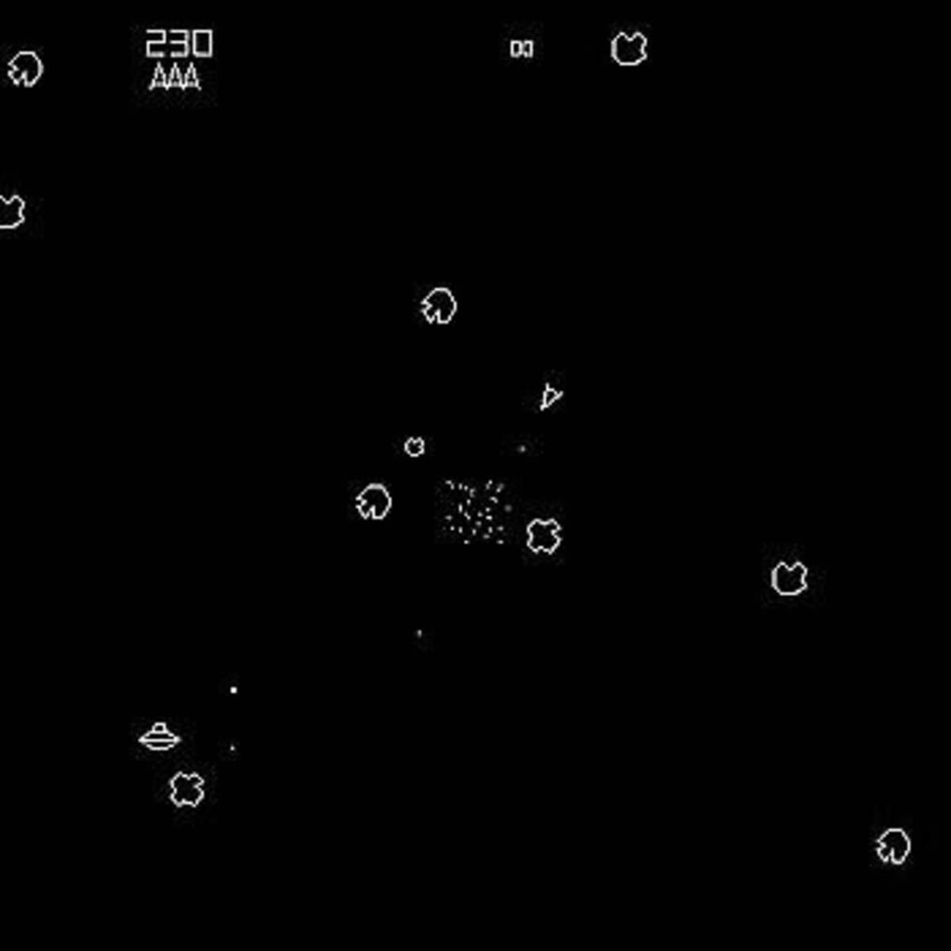 (but in 3d and unity)  
(and instead of lives health)